**Ideation Phase**

**House Hunt & Idea Prioritization Template**

|  |  |
| --- | --- |
| Date | June 2025 |
| Team ID | LTVIP2025TMID57321 |
| Project Name | House Hunt: Finding Your Perfect Rental Home |
| Maximum Marks | 4 Marks |

**House Hunt & Idea Prioritization Template:**

The House Hunt Project is a comprehensive initiative designed to simplify the complex process of finding a residential property. Whether the goal is to buy, rent, or invest, this project enables informed decision-making through structured research, budgeting, site evaluations, and prioritization methods.

To identify, evaluate, and select the most suitable residential property based on budget, location, lifestyle, and future value using a structured decision-making process.

**Major challenges for House Hunt:**

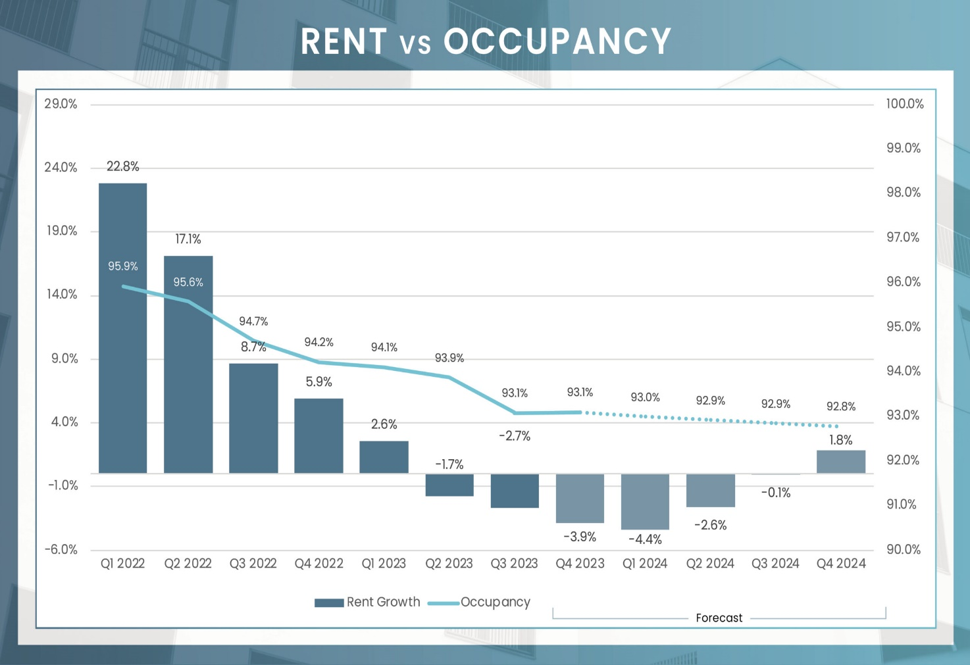

**Problem Discovery**

**Objective:**

To find and secure a residential property that best fits a person’s or family’s needs, preferences, and budget, while ensuring legal clarity, safety, and long-term value.

**Common House hunt main Points:**

* Set your budget for buying or renting
* Ensure ownership clarity, approvals, and registration
* To find a residential property that fits your needs, budget, and lifestyle
* Life time alignment and property investment
* Consider safety, commute, amenities, and future value

**Common Client Pain Points:**

* Discrepancies between photos and actual property condition
* Shortage of quality properties in preferred locations.
* Too many platforms to monitor (apps, agents, word of mouth)
* Commission-driven behavior rather than client-first approach
* Buyers struggle to understand property documents and legalities